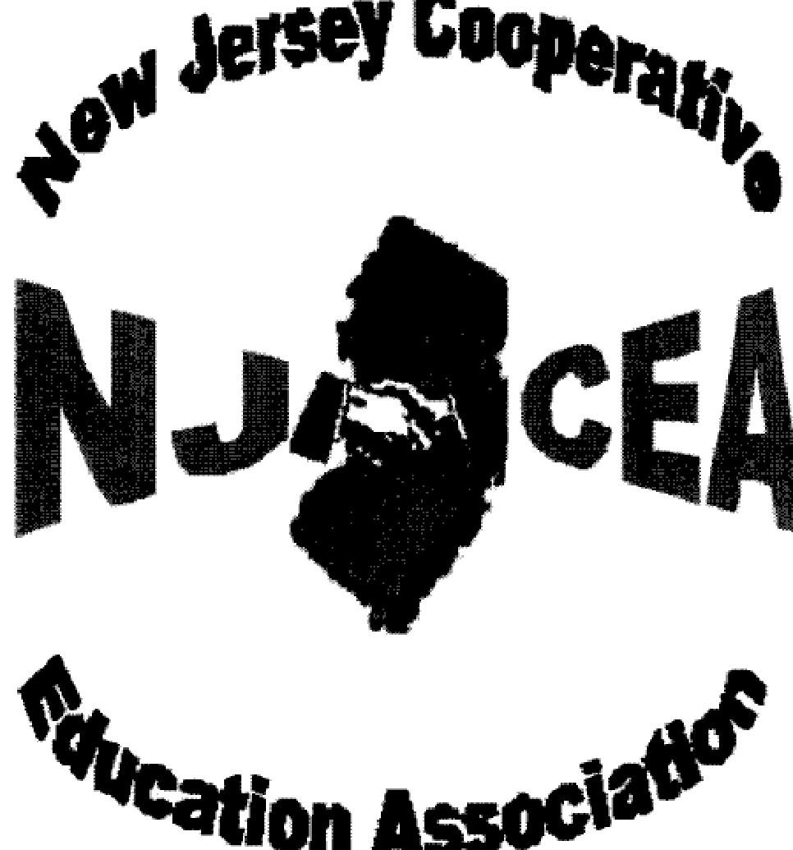

New Jersey Cooperative Education Association

APPLICATION FOR MEMBERSHIP 2022-2023

Benefits include:

* Free Regional Meetings
* Scholarship opportunities for co-op students
* Complimentary outstanding student plaques
* Licensing updates and administrative code information
* Worksite safety and health information, and
* Most importantly, networking and feedback regarding programs
Please Print Clearly
NAME: __________________________ Check if all information is same as last year □

Complete only if new or changed

SCHOOL: __________________________ Title ________________________________

SCHOOL ADDRESS: ___________________________________________________

___________________________________________________

SCHOOL PHONE: _(______)_______________FAX: _(______)________________

SCHOOL E-MAIL ADDRESS: ____________________________________________

HOME ADDRESS: _____________________________________________________

_____________________________________________________

HOME TELEPHONE: __(_____)___________________________________________

HOME E-MAIL ADDRESS: _______________________________________________

If you are a new NJCEA member, please write the name of the coordinator who referred you. They will receive a $5 credit toward next year’s dues _______________________

Application along with payment or purchase order due by December 1, 2023

Active Membership Fee: $40.00 Retired Membership Fee: $15.00

Student Membership Fee: $10

Make Check Payable to: NJCEA

Mailing Address for membership: R. Carson
NJCEA
314 Westminster Avenue
Cherry Hill, NJ 08002

Questions, please e-mail: Rob Carson rcarson@burltwpsch.org or
rcarson@njcea.info

